|  |  |  |  |  |  |  |  |  |  |  |  |  |  |  |  |  |  |  |  |  |  |  |  |  |  |  |
| --- | --- | --- | --- | --- | --- | --- | --- | --- | --- | --- | --- | --- | --- | --- | --- | --- | --- | --- | --- | --- | --- | --- | --- | --- | --- | --- |
|  | Project Name:Setup a Lane keeping assistance system evaluation demonstration using NXP SBC-S32V234 Evaluation Board | | | | | | | | | | | | | | | | | | | | | Date:24.05.19 | | | | |
| Nr. | Year | 2019 | | | | | | | | | | | | | | | | | | | | | | | | |
| Month | April | | | | May | | | | June | | | | July | | | | August | | | | | September | | | |
| Week | 1 | 2 | 3 | 4 | 5 | 6 | 7 | 8 | 9 | 10 | 11 | 12 | 13 | 14 | 15 | 16 | 17 | 18 | 19 | 20 | | 21 | 22 | 23 | 24 |
|  | S32V234 Board Evaluation |  |  |  |  |  |  |  |  |  |  |  |  |  |  |  |  |  |  |  |  | |  |  |  |  |
| S32DS Software Installation |  |  |  |  |  |  |  |  |  |  |  |  |  |  |  |  |  |  |  |  | |  |  |  |  |
| Running Demo project on Emulator |  |  |  |  |  |  |  |  |  |  |  |  |  |  |  |  |  |  |  |  | |  |  |  |  |
| Preparation of SD Card |  |  |  |  |  |  |  |  |  |  |  |  |  |  |  |  |  |  |  |  | |  |  |  |  |
|  | Creation of own Demo Project |  |  |  |  |  |  |  |  |  |  |  |  |  |  |  |  |  |  |  |  | |  |  |  |  |
|  | Camera setup |  |  |  |  |  |  |  |  |  |  |  |  |  |  |  |  |  |  |  |  | |  |  |  |  |
|  | NXP Setup Environment |  |  |  |  |  |  |  |  |  |  |  |  |  |  |  |  |  |  |  |  | |  |  |  |  |
|  | Analyzing Vision SDK architecture and change in required programming |  |  |  |  |  |  |  |  |  |  |  |  |  |  |  |  |  |  |  |  | |  |  |  |  |
| Image processing and calculation of required parameters on NXP Board |  |  |  |  |  |  |  |  |  |  |  |  |  |  |  |  |  |  |  |  | |  |  |  |  |
| Sending Image and required parameters to Simulator via CAN bus and Ethernet Bus |  |  |  |  |  |  |  |  |  |  |  |  |  |  |  |  |  |  |  |  | |  |  |  |  |
| Comparison of calculated data with ground truth Simulated Environment |  |  |  |  |  |  |  |  |  |  |  |  |  |  |  |  |  |  |  |  | |  |  |  |  |
|  | Probable errors fine tuning |  |  |  |  |  |  |  |  |  |  |  |  |  |  |  |  |  |  |  |  | |  |  |  |  |
|  | Documentation and writing thesis report |  |  |  |  |  |  |  |  |  |  |  |  |  |  |  |  |  |  |  |  | |  |  |  |  |

**Overview of the Board and software:**

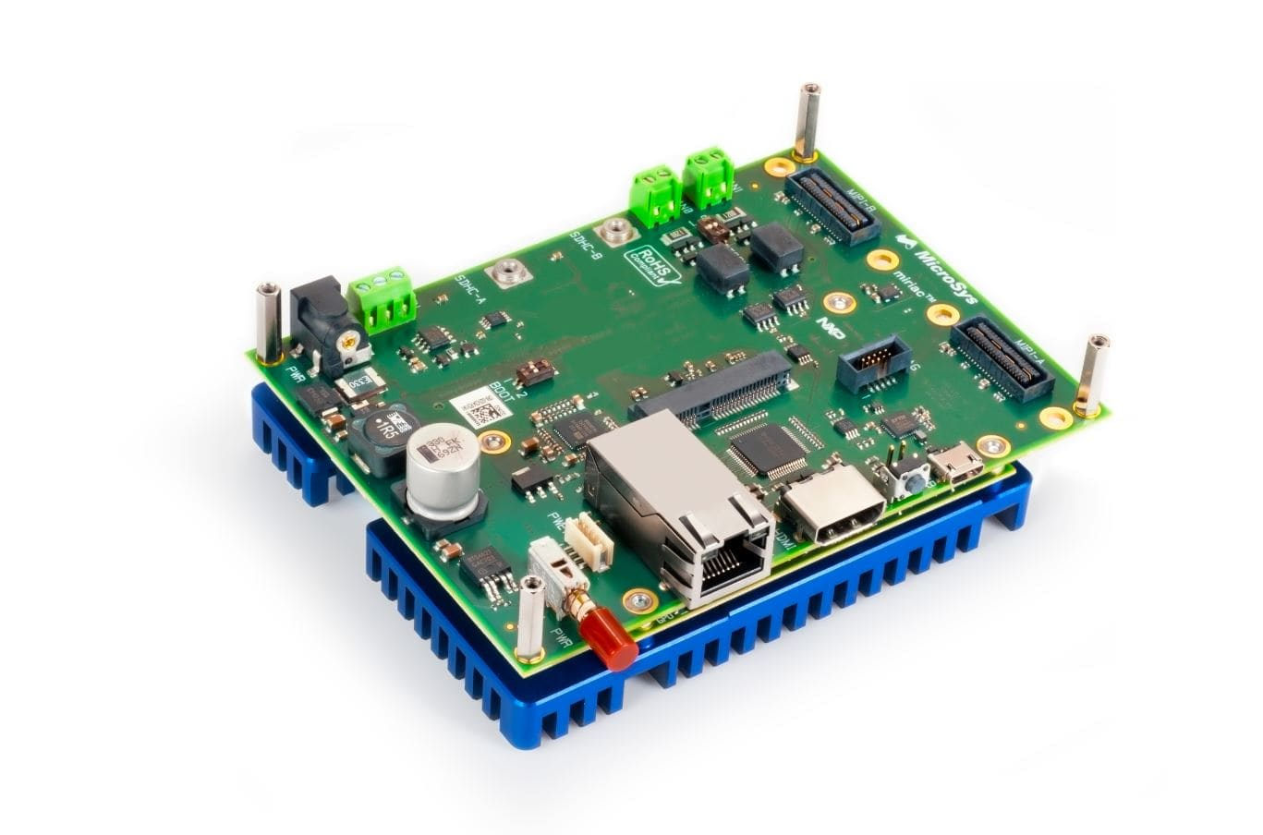

The SBC-S32V234 is a low-cost development platform for the S32V2 vision processor. The Module board contains S32V234 processor, memories and power regulators for the module board and the Carrier board contains all system specific i/o like camera connectors, ethernet port, display port, SD card slot, CAN ports etc.Total 8 cameras can be connected to the Board through deserializer.In this project MXOV10635-S32V camera have been used. The deserializer board model is MAX9286S32V234.S32DS 2018.R1 for Vision software will be used for simulation.

**Lesson learned and Challenges:**

At first S32DS 2018.R1 software were installed on Ubuntu 18.4. But S32 DS for Vision only supports Ubuntu 16.4 and openjdk-8.After installing Ubuntu 16.4 and openjdk-8 the required software has been installed successfully.From APEX graph project APEX program project and APEX application project is created accordingly using S32DS software on Linux.ISP dataflow project and ISP application project is also created using S32DS for vision software.

**Hardware Setup**: 1. On S32-SBC PWA jumper connected to 12V power to power deserializer board. 2. On S32-SBC the MAX deserializer board is connected to the MIPI-A. 3. On MAX deserializer board jumper JU4 is set to power the camera from SBC board (After setting the jumper the yellow light of each cameras are lit). The full hardware setup image is given below:

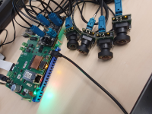

**Software Setup:** The SD card is prepared with SDK_S32V2_RTM_1_3_0_img_yocto.tar.gz.After preparing the sd card it is inserted to the evaluation board. Camera captured images will be displayed on the HDMI connected display unit. Power on the boot, login and change directory to the demo folder.Then the sample application isp_ov10635_quad.elf was running on the board using the command root@s32v234sbc:~/vsdk# ./isp_ov10635_quad.elf

